|  |  |  |  |  |
| --- | --- | --- | --- | --- |
|  |  |  |  |  |

|  |  |  |  |
| --- | --- | --- | --- |
| PROCEDURES CHECKLIST | | | |
| **Date (YYYY-MM-DD):** | | | **People responsible for the igniter preparing:** |
| **Components:**  **1) Potassium nitrate (KNO3)**  **2) Sorbitol (C6H14O6)**  **3) Aluminum (mean particle diameter<40μm)** | | | **Number of items:** |
| **mAl=**  **mKNO3=**  **mC6H14O6=** | | | **migniter=** |
| **#** | **Status** | **Activity** | |
| 1. | [ ] | Read the safety rules and the preparing instruction. Put on protective clothing. | |
| 2. | [ ] | Gather all materials needed (KNO3, sorbitol (C6H14O6), aluminum (mean particle diameter<40μm), forms, pan or pot, paddle e.g. silicone or wooden spatula, plastic cups, paper towel, plastic, ceramic or wooden tea spoon). Check the compliance of the components with their drawings. | |
| 3. | [ ] | Make sure that the elements have been cleaned. | |
| 4. | [ ] | Crumble the KNO3 and sorbitol using spatula. | |
| 5. | [ ] | Admeasure proper amount of the ingredients into separate cups ( g of KNO3, g of sorbitol, g of aluminum in 55 : 29 : 16 ratio). | |
| 6. | [ ] | Mix the ingredients dry in one cup. | |
| 7. | [ ] | Add water to mixture using tea spoon and mix it for 3 minutes until unified consistency. The amount of added water should be between 3-5 tea spoons. When adding more water, the process of cooking will take more time for water vaporisation. | |
| 8. |  | Pour mixture into cooking pan and start cooking while constantly mixing ingredients in the pan on middle fire. | |
| 9. | [ ] | Cook the carmel until paste consistency. | |
| 10. | [ ] | Funnel the carmel to form quickly. Depending on gained consistency, carmel can have to be pushed into the form to avoid air bubbles forming within material. It can be pushed using backside of the tea spoon. | |
| 11. | [ ] | Remove overflow leaving approximately 3mm of free space above the carmel surface in the form. To do it, the backside of spoon can be used also. | |
| 12. | [ ] | Dab the cover plate to make sure it fits. Then remove the cover before carmel bonding. | |
| 13. | [ ] | Leave the igniter to dry (e.g. in rice, on radiator) for a few days. | |
| **Notes:**  **Photos:** | | | |
|  | | | |

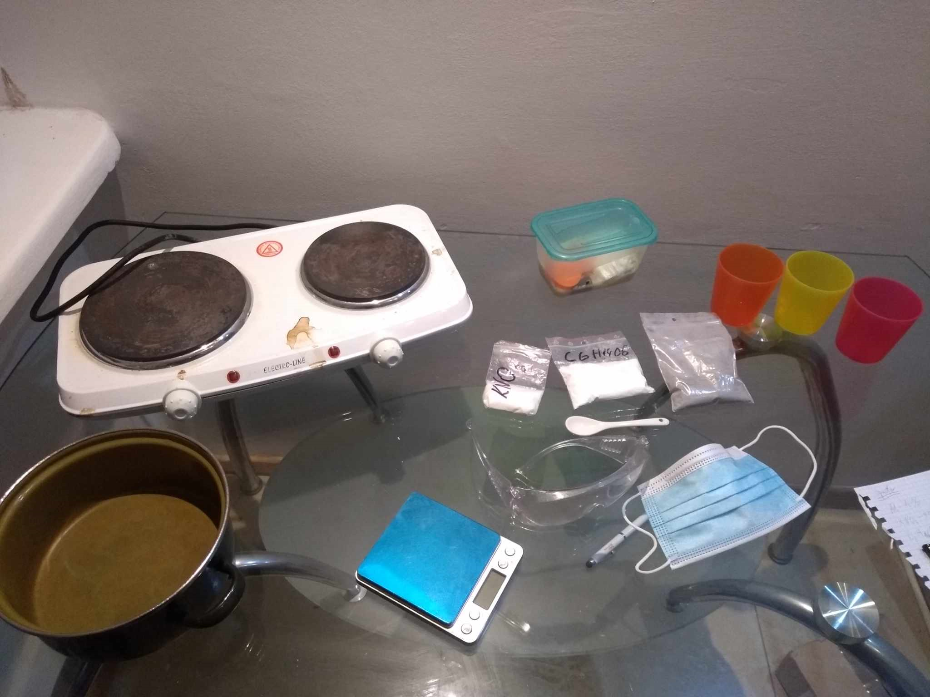

Fig. 1 Items prepared for cooking

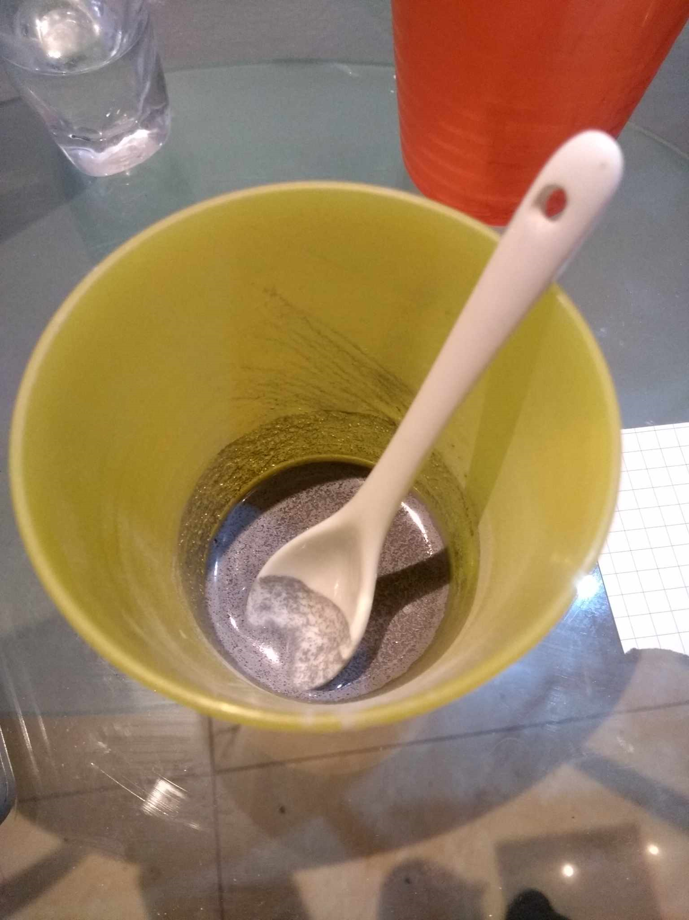

Fig 2. Mixed components with added water

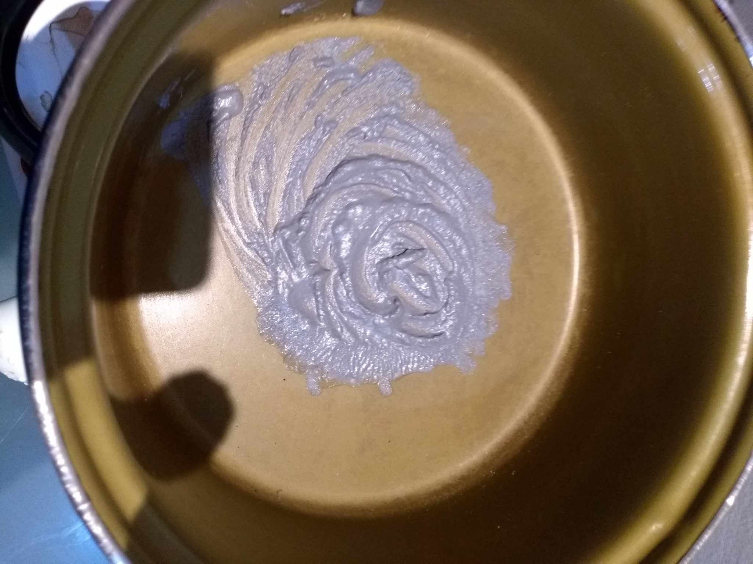

Fig. 3 Carmel state before pouring

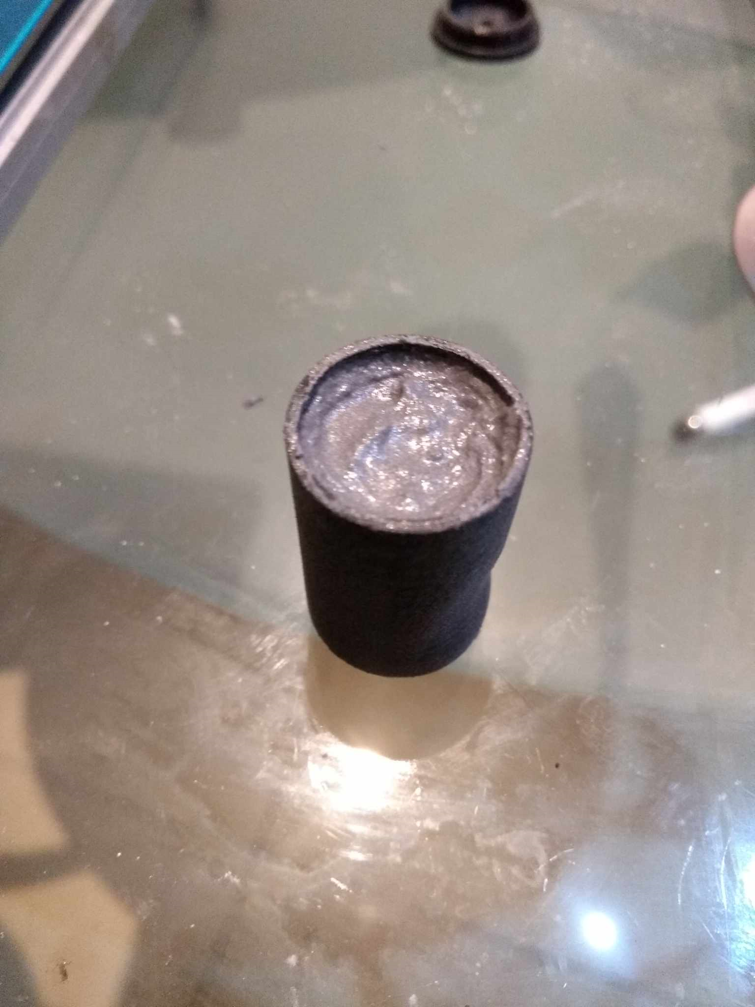

Fig. 4 Carmel poured into the form